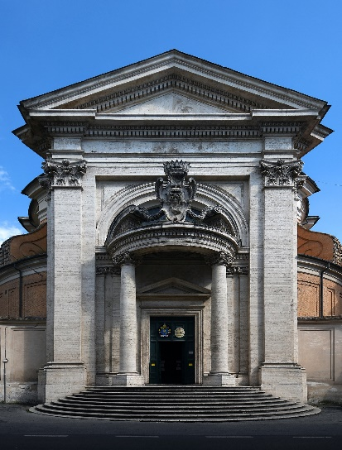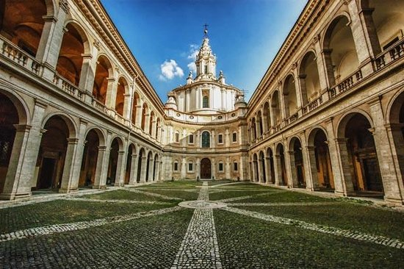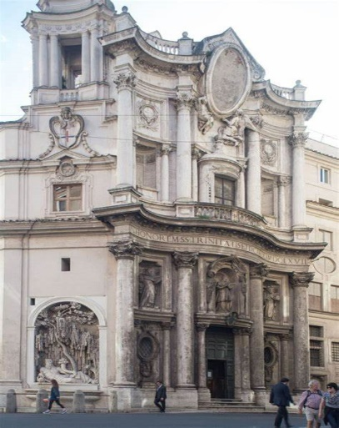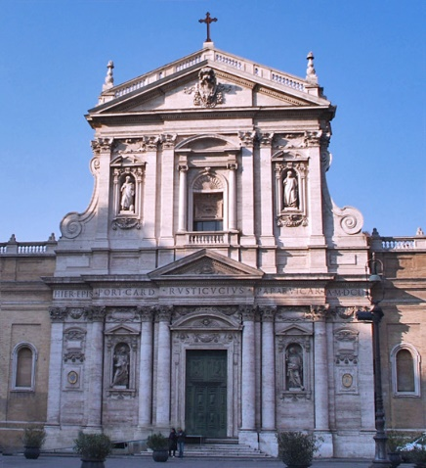

4

3

2

1.

The tour continues to Piazza Sant’Eustachio to visit the tiny Church of Sant’Ivo della Sapienza, a masterpiece of Baroque architecture and built by Francesco Borromini.

Continuing along the street, we head for the Church of Sant’ Andrea al Quirinale, called the “pearl” of the Baroque for the precious materials used in the decorations.

The next stop is in Via Viminale for a visit to the Church of San Carlo alle quattro Fontane by Borromini.

Church of Santa Maria della Vittoria a real masterpiece by Bernini: the status of Saint Theresa in the Cornaro Chapel.